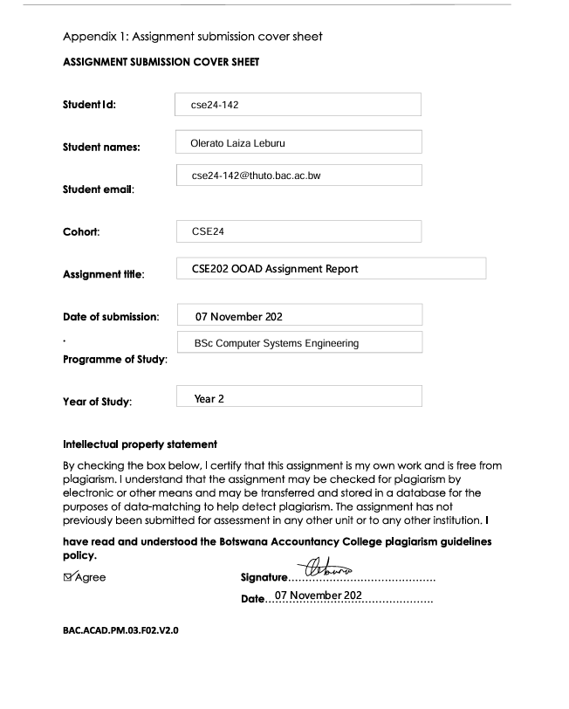

5

5

Introduction
This report details the integration testing performed on the fully developed banking system. The goal is to verify that all components — from the GUI (View) through the Controller, to the Core Model (Entity/Service), and finally to database persistence via JDBC — work together properly.
The test simulates a real-world user flow:
Customer logs in → deposits funds → withdrawal attempt (blocked) → views transaction history → logout
Teller opens new Investment Account → customer logs in with new PIN → verifies account access
All functional and non-functional requirements are validated during this process.

Objectives
- Verify end-to-end login and transaction flow
- Confirm controller handles input correctly
- Validate model enforces business rules
- Ensure transactions are logged and balance updated atomically
- Demonstrate a polymorphic interest application

Test Case 1: Full User Flow
- Launch App
Expected Result: Customer Login screen appears
- Enter Account: AC100001, PIN: 1234 and click Login
Expected Result: Dashboard opens
- Select any account (e.g., Cheque or Investment)
Expected Result: Account selected in the dropdown
- Click Deposit → Enter 1000.00 → OK
Expected Result: Success alert: “Deposited 1000.00 BWP”
- Observe transaction preview list
Expected Result: New deposit entry visible immediately
- Click Withdraw on same account → Enter 500.00
Expected Result: Success alert: “Withdrew 500.00 BWP”
- Switch to Savings Account → Click Withdraw
Expected Result: Error Alert: "Withdrawal not allowed from Savings Account."
- Click View History
Expected Result: Full window opens showing:
• Deposit: 1000.00
• Withdrawal: 500.00
- Close history → Click Logout
Expected Result: Dashboard closes → Login screen reappears

Test Case 2: Teller opens a new account, and the customer logs in
- On the Teller Dashboard, click Open Investment Account
Expected Result: Form appears
- Enter new account number: ACC100003
Expected Result: Accepted as valid
- Initial Deposit: 600.00
Expected Result: Valid (≥ BWP500)
- Set PIN: 9999
Expected Result: Field accepts 4-digit input
- Click Open Account
Expected Result: Success alert: “Investment account opened successfully!”
- Close teller panel → Return to login screen
Expected Result: Back to customer login
- Log in with: Acc = ACC100003, PIN = 9999
Expected Result: Dashboard opens successfully
- Check account list
Expected Result: Shows newly created Investment Account

Conclusion
The integration tests confirm that:
- The GUI (JavaFX) correctly captures user input and displays results.
- The controllers properly validate and route requests.
- The core model enforces business logic:
  - No withdrawals from Savings
  - Minimum BWP500 for Investment
- The system supports full OOP principles: abstraction, inheritance, polymorphism, and encapsulation.
- All non-functional requirements (security, usability, reliability, maintainability) are met.

